Department of Data Science & forecasting
M.Tech – Data Science
Class – Working Executives
Subject : Data Mining and Data Warehousing
Subject Code : DS7E-702
Assignment - SEM-II

Data Mining

Q.1 What is the primary purpose of data warehouse?

Ans. The primary purpose of a data warehouse is to store large amounts of integrated and historical data collected from different sources. It is mainly used for data analysis, reporting, and decision-making rather than daily transactions. A data warehouse helps organizations identify trends, patterns, and business insights over time and supports strategic planning.

Q.2 How does the data warehouse different from a standard database?
Ans. A data warehouse is different from a standard database because a standard database is designed for routine transaction processing, while a data warehouse is designed for analytical processing. Standard databases handle current data with frequent updates, whereas data warehouses store historical data and are mostly read-only. Data warehouses are optimized for complex queries and reporting.
Q.3 Explain the ETL process ?
Ans. The ETL process stands for Extract, Transform, and Load. In the extract phase, data is collected from multiple source systems. In the transform phase, data is cleaned, validated, and converted into a suitable format. In the load phase, the transformed data is stored in the data warehouse for analysis and reporting purposes.
Q.4 What is the difference b/w structured and unstructured data?
Ans. Structured data is data that is organized in a fixed format such as rows and columns and is stored in databases or spreadsheets. It is easy to search and analyze using SQL queries. Unstructured data does not have a predefined format and includes data such as emails, images, videos, and documents. Unstructured data is more difficult to process and analyze.
Q.5 what is Data Mart and example?
Ans. A Data Mart is a smaller, focused version of a data warehouse that serves a specific department or business function. It contains only relevant data needed by that department. Data marts improve query performance and are easier to manage. For example, a sales data mart is used to analyze sales performance.
Q.6 what is Fact and dimension table and difference b/w them?
Ans. A fact table stores numerical and measurable data such as sales amount or quantity sold. A dimension table stores descriptive information such as customer, product, or time details. Fact tables are large and contain foreign keys, while dimension tables are smaller and provide context to the facts.
Q.7 What is meta data and example ?
Ans. Metadata is data that describes other data. It provides information about data structure, data types, source, and meaning. Metadata helps users understand and manage data effectively. For example, a column name with its data type is metadata.
Q.8 Difference b/w OLTP and OLAP ?
Ans. OLTP systems are used for day-to-day transaction processing and handle many small operations. OLAP systems are used for data analysis and support complex queries. OLTP focuses on current data, while OLAP works with historical data.
Q.9 What is Schema in a data warehouse and explain type ?
Ans. A schema in a data warehouse defines how data is organized and how tables are related. The main types of schemas are star schema, snowflake schema, and galaxy schema, each used for efficient data analysis.
Q.10 What is BI tool ?
Ans. A BI tool is software used to analyze data and present insights through reports and dashboards. It helps organizations make informed business decisions.

Data warehouse
Q.1. What is the simplest definition of Data Mining?
Ans. Data mining is the process of discovering useful patterns, relationships, and knowledge from large volumes of data. It involves analyzing data using statistical, mathematical, and machine learning techniques. The main goal of data mining is to extract meaningful information that can support decision-making. It transforms raw data into valuable insights. Data mining is a key step in knowledge discovery.
Q.2 Describe the iterative nature of KDD?
Ans. Knowledge Discovery in Databases (KDD) is an iterative and interactive process used to extract useful knowledge from large datasets. It involves multiple stages including data selection, data preprocessing, data transformation, data mining, and interpretation of results. These stages are not executed only once but are repeated several times until meaningful and accurate knowledge is obtained. If errors or irrelevant patterns are discovered during analysis, the process returns to earlier stages for refinement. Human involvement plays an important role in evaluating intermediate results. The iterative nature of KDD ensures continuous improvement in data quality and discovered knowledge.
Knowledge Discovery in Databases (KDD) is a comprehensive and systematic process used to extract useful, valid, novel, and understandable knowledge from large volumes of data. One of the most important characteristics of KDD is its iterative nature, meaning that the process does not proceed in a strictly linear sequence but involves repeated cycles of refinement and feedback at different stages.
Meaning of Iterative Nature in KDD
The iterative nature of KDD refers to the fact that insights gained at any stage of the process can lead to revisiting and revising earlier steps. Data mining is not a one-time activity; instead, it is a continuous learning process where intermediate results influence subsequent actions and decisions.
This iteration is necessary because real-world data is often incomplete, noisy, and complex, and initial assumptions may not always produce meaningful or accurate knowledge.
Stages of KDD and Iteration
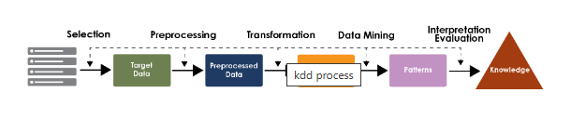
The KDD process typically consists of the following stages:
- Data selection
- Data preprocessing (cleaning)
- Data transformation
- Data mining
- Pattern evaluation
- Knowledge presentation
At each stage, feedback may require adjustments to previous steps, making the process iterative.
How Iteration Occurs in KDD
- During data preprocessing, issues such as missing values or noise may require re-selection or additional data collection.
- In data transformation, inappropriate feature selection or scaling may be identified after mining results are analyzed.
- During data mining, choosing an unsuitable algorithm or parameter settings may lead to poor patterns, requiring algorithm changes or data reprocessing.
- In pattern evaluation, discovered patterns may be irrelevant or redundant, prompting refinement of mining objectives or thresholds.
- Knowledge presentation may reveal the need for further mining with different constraints or perspectives.
Thus, each phase can trigger backtracking and refinement.
Importance of Iterative Nature
The iterative nature of KDD is crucial because it:
- Improves the quality and accuracy of discovered knowledge
- Helps in refining goals and hypotheses
- Allows incorporation of domain knowledge
- Adapts to changing data and business requirements
- Ensures meaningful and actionable insights
Iteration enables continuous improvement until the discovered patterns satisfy user objectives.
In conclusion, the iterative nature of KDD reflects the reality that knowledge discovery is an evolving and adaptive process rather than a linear pipeline. Continuous feedback, refinement, and repetition across different stages ensure that the final knowledge extracted from data is accurate, relevant, and valuable for decision-making. This iterative approach makes KDD a robust and effective framework for real-world data mining applications.

Q.3 What is the data smoothing and which theoretical technique are used to handle "Noisy Data"?
Ans. In data mining and data preprocessing, noisy data refers to data that contains errors, random variations, outliers, or inconsistencies that do not represent true underlying patterns. Noise can arise due to measurement errors, data entry mistakes, transmission problems, or natural variability in real-world processes. To improve data quality and ensure reliable analysis, a technique known as data smoothing is commonly used.
Data Smoothing -Data smoothing is a data preprocessing technique used to reduce noise and irregularities in datasets while preserving important trends and patterns. The main objective of data smoothing is to make data more consistent and suitable for further analysis such as classification, clustering, and prediction.
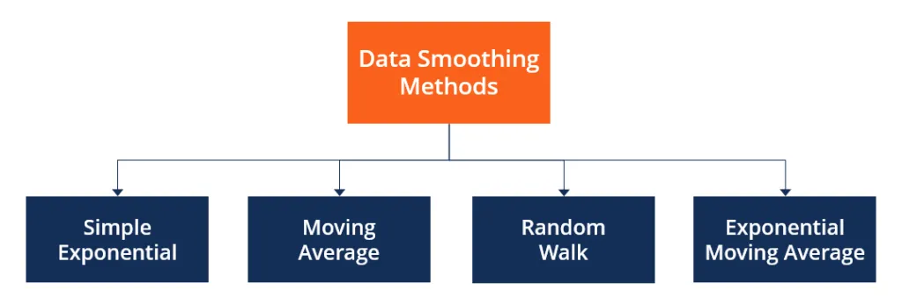

By eliminating minor fluctuations and random errors, smoothing helps in:
- Improving data quality
- Enhancing model accuracy
- Reducing the impact of outliers
- Revealing underlying data trends
Theoretical Techniques for Handling Noisy Data
Several theoretical and statistical techniques are used for data smoothing. The most important ones are described below:
1. Binning Method -Binning is a simple and commonly used smoothing technique. In this method, data values are sorted and divided into a number of bins (intervals). Each bin is then smoothed using:
- Bin mean: Replace all values in a bin with the mean of the bin
- Bin median: Replace values with the median of the bin
- Bin boundaries: Replace values with the nearest boundary value
Binning reduces the effect of minor noise by grouping nearby values.
2. Regression-Based Smoothing -Regression techniques fit a mathematical model (such as linear or polynomial regression) to the data. The fitted function represents the underlying trend, while deviations from the trend are treated as noise.
Regression smoothing is effective when:
- A clear relationship exists between variables
- The goal is trend estimation and prediction
3. Clustering-Based Smoothing –
In this technique, similar data points are grouped into clusters. Data points that do not belong strongly to any cluster or fall far from cluster centers are considered noise or outliers and can be removed or adjusted.
Clustering-based smoothing is useful for:
- Multidimensional data
- Identifying abnormal or noisy records
4. Moving Average Method
The moving average technique replaces each data value with the average of neighboring values within a defined window. It is widely used in time-series data to smooth short-term fluctuations.
This method helps in:
- Reducing random variation
- Highlighting long-term trends
5. Statistical Filtering Techniques
Statistical methods such as mean filtering, median filtering, and Gaussian smoothing are also used to reduce noise. Median filtering is particularly effective in handling outliers, as it is less sensitive to extreme values.
Conclusion
Data smoothing is an essential data preprocessing step used to handle noisy data by reducing random errors and fluctuations while preserving meaningful patterns. Theoretical techniques such as binning, regression, clustering, moving averages, and statistical filtering play a crucial role in improving data quality. Effective smoothing leads to better data analysis, more accurate models, and reliable decision-making in data mining and machine learning applications.

Q.4 In association rule mining , what is the mathematical difference b/w support and confidence?
Ans. Support and confidence are key measures used in association rule mining to evaluate the usefulness of rules. Support represents the frequency of an itemset in the entire database and indicates how often a rule occurs.
Association rule mining is a core task in data mining used to discover interesting relationships among variables in large transactional datasets. Two fundamental statistical measures used to evaluate the strength and usefulness of association rules are support and confidence. Although both are derived from transaction frequencies, they differ mathematically and conceptually in what they measure.
Mathematically, support is calculated as the number of transactions containing the itemset divided by the total number of transactions. Confidence represents the strength or reliability of a rule. It is calculated as the ratio of transactions containing both antecedent and consequent to those containing only the antecedent. Support measures popularity, while confidence measures predictive strength.
Support
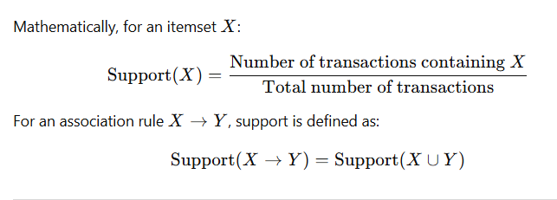
Definition -Support measures the frequency or prevalence of an itemset in the entire transaction database. It indicates how often a particular item or combination of items appears across all transactions.

Mathematical Interpretation -
Support is a global probability measure. It represents the probability that a randomly selected transaction from the database contains both X and Y.
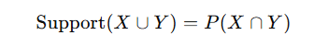
Thus, support reflects the statistical significance or importance of a rule in the dataset as a whole.
Purpose of Support
- Filters out rare or insignificant itemsets
- Ensures rules are based on sufficient data
- Reduces computational complexity
A rule with very low support may not be useful in practice, even if it has high confidence.
Confidence
Definition -Confidence measures the conditional probability that a transaction contains itemset Y, given that it already contains itemset X.
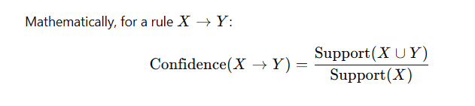
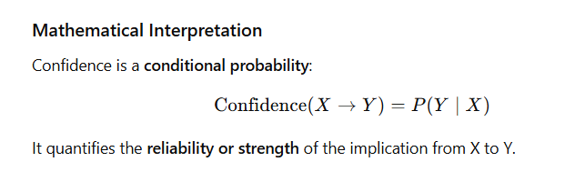

Purpose of Confidence
- Measures predictive power of the rule
- Indicates how often Y occurs when X occurs
- Helps assess rule usefulness for decision-making
A rule with high confidence suggests a strong association, but it may still be misleading if Y is very common in the dataset.
Mathematical Difference Between Support and Confidence
Aspect | Support | Confidence
Mathematical Nature | Joint probability | Conditional probability
Formula | ( P(X \cap Y) ) | ( P(Y \mid X) )
Denominator | Total transactions | Transactions containing X
Scope | Entire dataset | Only transactions with X
Purpose | Frequency and significance | Strength of implication
Threshold Type | Minimum support | Minimum confidence

Illustrative Example-
Assume a database with 100 transactions:
40 transactions contain item A
30 transactions contain both A and B
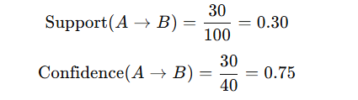
This means:
30% of all transactions contain both A and B (support)
75% of transactions that contain A also contain B (confidence)
Key Observations
- Support measures how common a rule is.
- Confidence measures how reliable the rule is.
- A rule can have high confidence but low support, making it statistically weak.
- Support does not imply causality; it only indicates co-occurrence.

Q.5 Explain the "centroid" concept in k-means clustering ?
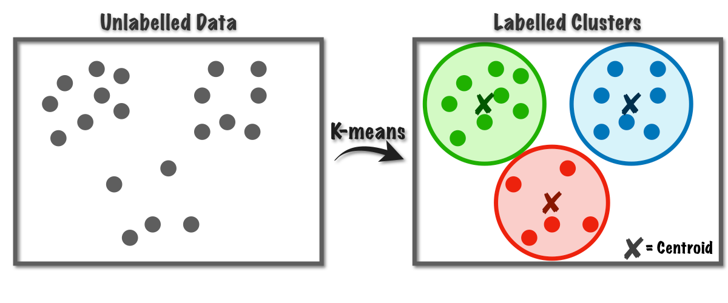
Ans. K-means clustering is one of the most widely used unsupervised learning algorithms for partitioning a dataset into K distinct clusters based on similarity. At the heart of this algorithm lies the concept of the centroid, which represents the central point of a cluster. Understanding the centroid concept is essential to understanding how k-means works, how clusters are formed, and how the algorithm converges.

Meaning of Centroid
A centroid is the geometric center or mean position of all the data points belonging to a particular cluster. In k-means clustering, each cluster is represented by exactly one centroid, and the position of this centroid is continuously updated during the clustering process.
Mathematically, if a cluster contains n data points (x₁,x₂,...,x_{n}) each with d dimensions, the centroid is calculated as the average of all points along each dimension:
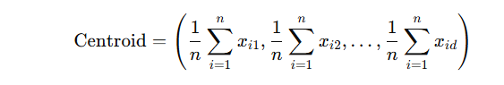
Thus, the centroid is not necessarily an actual data point from the dataset; rather, it is a computed point that summarizes the cluster.
Role of Centroid in K-Means Algorithm-
The centroid plays a central role in all stages of the k-means algorithm:
1. Initialization-Initially, K centroids are chosen, either randomly or using smarter initialization techniques such as k-means++. The initial positions of centroids strongly influence the final clustering outcome.
2. Assignment Step-Each data point in the dataset is assigned to the nearest centroid, typically using Euclidean distance. This step forms K clusters by grouping points around centroids.
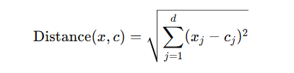
3. Update Step- Once points are assigned, the centroid of each cluster is recalculated as the mean of all data points currently assigned to that cluster. This step shifts the centroid toward the densest region of the cluster.
4. Iteration and Convergence -The assignment and update steps are repeated until centroids no longer change significantly or data point assignments remain stable. At convergence, centroids represent the final cluster centers.

Centroid as an Optimization Objective –
K-means clustering aims to minimize the within-cluster sum of squared distances (WCSS) between data points and their respective centroids:

Here, μ_{k} represents the centroid of cluster C_{k} . The centroid is the point that minimizes the total squared distance to all points in the cluster, which explains why the mean is chosen instead of other measures like median.
Characteristics of Centroids
- Computed, not observed: Centroids are usually not actual data points.
- Sensitive to outliers: Since centroids are means, extreme values can significantly shift their position.
- Dynamic: Centroids change positions during iterations.
- Dimension-dependent: Each feature contributes equally unless data is normalized.
Limitations of Centroid Concept
- Assumes clusters are spherical and equally sized
- Performs poorly on non-convex clusters
- Sensitive to initialization and noise
- Requires numeric data
The centroid is the core concept in k-means clustering, acting as the representative center of each cluster. By iteratively assigning data points to the nearest centroid and recalculating centroid positions, k-means efficiently partitions data into meaningful groups. While simple and computationally efficient, the centroid-based approach also introduces limitations related to sensitivity to outliers, scaling, and cluster shape assumptions. Despite these limitations, the centroid concept remains fundamental to clustering and unsupervised learning in data mining and machine learning.

Q.6 What are the theoretical limitations of the apriori algorithm regarding large data sets?
Ans. The Apriori algorithm is one of the earliest and most widely known algorithms for frequent itemset mining and association rule discovery in data mining. It is based on the Apriori principle, which states that all non-empty subsets of a frequent item set must also be frequent. While Apriori is conceptually simple and theoretically sound, it suffers from several theoretical and practical limitations, especially when applied to large-scale data sets with high dimensionality and massive transaction volumes.
Apriori works in a level-wise, breadth-first manner. It starts by identifying frequent 1-itemsets and iteratively generates candidate itemsets of increasing size (2-itemsets, 3-itemsets, etc.). At each level, it scans the database to count the support of candidates and prunes those that do not meet the minimum support threshold. Although effective for small to medium-sized data sets, this process becomes increasingly inefficient as data size grows.

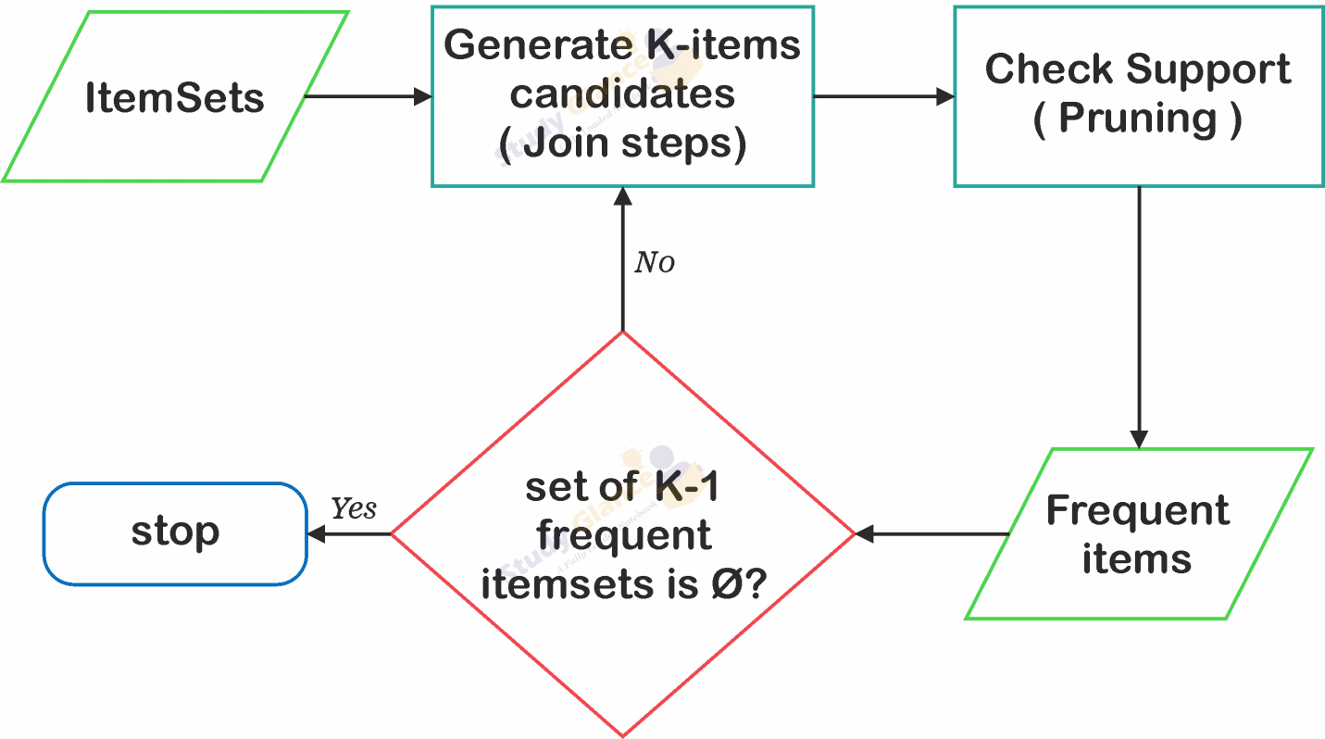

Theoretical Limitations of Apriori on Large Data Sets
1. Exponential Growth of Candidate Item sets -One of the most fundamental limitations of the Apriori algorithm is the combinatorial explosion of candidate item sets.
If a dataset contains n unique items, the total possible number of itemsets is 2 ^{n−1.}
As the number of frequent items increases, the number of candidate item sets grows exponentially. For large datasets with thousands of items, even after pruning, the number of candidates can become extremely large, leading to excessive computation and memory usage.
Theoretical implication:Apriori has exponential time complexity in the worst case, making it unsuitable for high-dimensional data.

2. Multiple Database Scans- Apriori requires multiple full scans of the transaction database—one for each level of itemset size.
First scan: frequent 1-itemsets
Second scan: frequent 2-itemsets
…
kth scan: frequent k-itemsets
For large datasets stored on disk or distributed systems, repeated scanning results in:
- High I/O cost
- Increased execution time
- Poor scalability
Theoretical limitation:
Apriori’s performance is bounded by the number of database passes, which increases linearly with the maximum length of frequent itemsets.

3. High Computational Complexity -The support counting process requires checking each candidate itemset against every transaction.For each candidate, Apriori must test whether it is a subset of a transaction.
As both the number of candidates and the number of transactions grow, computational cost increases dramatically.This leads to quadratic or worse complexity with respect to the size of the dataset.
Impact on large datasets: The algorithm becomes computationally infeasible as transaction volume reaches millions or billions.
4. Memory Consumption Issues-Apriori stores large candidate sets in memory during execution. Candidate itemsets at higher levels can be extremely large. Memory requirements grow rapidly with dataset size.
In large datasets, this can lead to:
- Memory overflow
- Excessive swapping
- Reduced system performance
Theoretical concern:Apriori is not memory-efficient for large-scale or high-dimensional datasets.
5. Sensitivity to Minimum Support Threshold-The performance of Apriori is highly sensitive to the minimum support value:
Low minimum support → very large number of frequent itemsets → explosion of candidates
High minimum support → important but less frequent patterns may be missed
For large datasets, selecting an optimal support threshold becomes difficult.
Theoretical limitation:There is no adaptive mechanism in Apriori to automatically adjust support thresholds based on dataset characteristics.
6. Poor Performance with Dense Data Sets-Apriori performs poorly on dense datasets, where transactions contain many items.
Dense data leads to longer frequent itemsets. More frequent subsets pass pruning, generating more candidates.
Examples include:
- Gene expression data
- Text mining
- Web usage logs
Theoretical implication:As data density increases, pruning effectiveness decreases, resulting in exponential growth in candidates.
7. Lack of Incremental and Dynamic Data Handling -Apriori assumes a static dataset.
When new transactions are added, the algorithm must be rerun from scratch.Previously computed frequent itemsets cannot be efficiently reused.
Limitation for large datasets:
In dynamic or streaming environments, Apriori is theoretically inefficient.
8. Limited Scalability in Distributed Environments -Although Apriori can be parallelized, its design is not inherently optimized for distributed or big data systems.Communication overhead increases with candidate exchange.Synchronization between nodes becomes costly.
Theoretical drawback:Apriori does not scale linearly with data size in distributed environments.

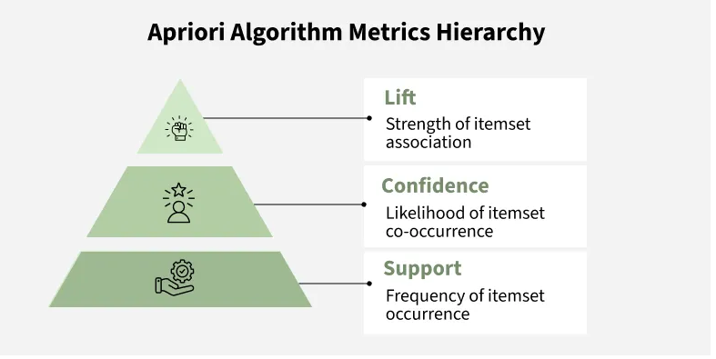

Q.7 What is "Overfitting" in predictive modeling, and how does "Pruning" address this in Decision Trees?
Ans. Predictive modeling aims to build models that can learn patterns from historical data and make accurate predictions on unseen or future data. A major challenge in this process is overfitting, which can significantly reduce a model’s real-world effectiveness. Decision Trees, while powerful and intuitive, are particularly prone to overfitting. Pruning is a key technique used to control this problem and improve model generalization.
Overfitting occurs when a predictive model learns not only the true underlying patterns in the training data but also the noise, random fluctuations, and outliers. As a result, the model performs extremely well on the training dataset but poorly on new, unseen data. In simple terms, an overfitted model is too complex and too closely tailored to the training data.
Overfitting represents a mismatch between model complexity and the amount or quality of data available. When a model becomes overly specialized, it loses its ability to generalize.
Characteristics of Overfitting
- Very high accuracy on training data
- Low accuracy on test or validation data
- Excessive model complexity
- High variance and sensitivity to small changes in data
- Poor predictive performance in real-world scenarios

Causes of Overfitting
- Several factors contribute to overfitting in predictive modeling:
- Excessive Model Complexity -Models with too many parameters (e.g., deep decision trees) can memorize training data.
- Small Training Dataset -Limited data encourages the model to fit every data point rather than learning general trends.
- Noisy Data -Errors, outliers, or irrelevant features may be mistakenly learned as important patterns.
- Too Many Features -Irrelevant or redundant features increase the risk of capturing noise.
- Lack of Regularization or Constraints -Without restrictions, the model continues to grow in complexity.
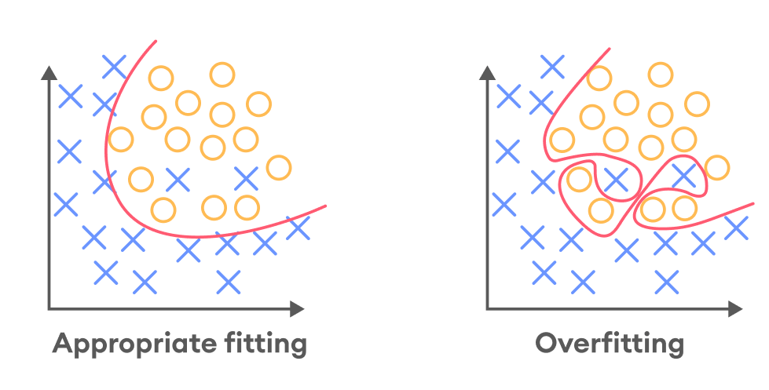
Overfitting in Decision Trees
Decision Trees are especially susceptible to overfitting because:
- They can grow very deep.
- They can create branches that perfectly classify training samples.
- They may create splits based on very small subsets of data.
- A fully grown decision tree may achieve 100% training accuracy, but this often leads to poor generalization.
Pruning in Decision Trees
Pruning is a technique used to reduce the size and complexity of a decision tree by removing unnecessary branches or nodes that contribute little to predictive power. The primary goal of pruning is to prevent overfitting and improve the model’s performance on unseen data.
Pruning simplifies the decision tree, making it more interpretable, robust, and generalizable.
How Pruning Addresses Overfitting
Pruning works by eliminating parts of the tree that capture noise rather than meaningful patterns. By restricting tree growth, pruning reduces variance and improves the bias–variance tradeoff.
Key benefits of pruning include:
- Improved generalization
- Reduced model complexity
- Better performance on test data
- Faster prediction time
- Increased interpretability

Types of Pruning in Decision Trees
1. Pre-Pruning (Early Stopping)
Pre-pruning stops the growth of the decision tree before it becomes too complex. By setting constraints, pre-pruning prevents the tree from learning very specific patterns that may not generalize .Minimum number of samples required to split a node. Minimum number of samples in a leaf node.Minimum impurity decrease (e.g., information gain threshold)
2. Post-Pruning (Pruning After Tree Growth)
Post-pruning allows the tree to grow fully and then removes branches that do not improve performance on validation data. Subtrees are replaced by leaf nodes.The effect on validation accuracy is evaluated.

Practical Importance of Pruning
In real-world applications such as medical diagnosis, financial risk assessment, and customer analytics, pruned decision trees are preferred because:
- They avoid misleading patterns
- They provide stable predictions
- They are easier to explain to stakeholders
- They perform better on real data
Aspect | Overfitted Tree | Pruned Tree
Tree Depth | Very deep | Controlled
Training Accuracy | Very high | Slightly lower
Test Accuracy | Low | Higher
Variance | High | Reduced
Interpretability | Poor | Better
Generalization | Weak | Strong

Conclusion
Overfitting is a critical problem in predictive modeling where a model performs well on training data but fails to generalize to unseen data. Decision Trees, due to their flexible and hierarchical nature, are particularly prone to overfitting. Pruning effectively addresses this issue by reducing unnecessary complexity and eliminating branches that capture noise rather than true patterns.
By applying pre-pruning or post-pruning techniques, decision trees achieve a better balance between accuracy and simplicity, leading to improved generalization, robustness, and interpretability. Therefore, pruning is an essential technique for building reliable and effective decision tree models in predictive analytics.

Q.8 What is market Basket analysis?
Ans. Market Basket Analysis (MBA) is a data mining and analytical technique used to understand and analyze customer purchasing behavior by identifying relationships and associations among products that are frequently purchased together. The concept is based on the idea that customers tend to buy certain items in combination, forming patterns that can be discovered from large transactional datasets. This technique is widely applied in retail, e-commerce, banking, and marketing analytics to support decision-making and strategy formulation.
Concept and Working Principle
Market Basket Analysis examines transaction data, where each transaction represents a “basket” of items purchased by a customer during a single shopping visit. By scanning large volumes of such transaction records, MBA identifies frequent item sets—groups of items that appear together more often than expected. From these item sets, association rules are generated in the form:
If a customer buys item A, they are likely to buy item B.
These rules help organizations understand product affinities and customer preferences. The underlying assumption of Market Basket Analysis is that the presence of certain items in a basket increases the likelihood of the presence of other related items.
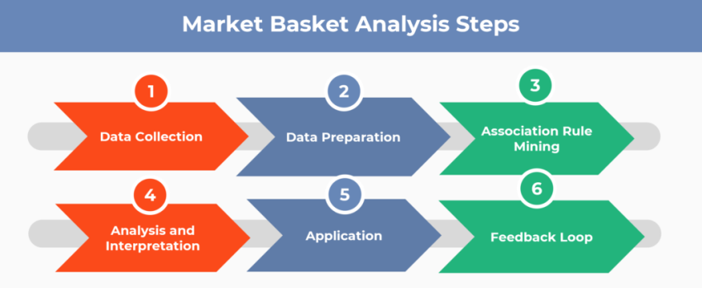

Association Rule Mining
Market Basket Analysis primarily uses association rule mining, which is a key task in data mining. The strength and usefulness of the generated rules are measured using three important parameters:
Lift
Lift evaluates the strength of a rule by comparing the observed co-occurrence of items with what would be expected if the items were independent. A lift value greater than 1 indicates a strong positive association.
Several algorithms are used to perform association rule mining, such as Apriori, FP-Growth, and ECLAT, which efficiently handle large datasets and extract meaningful patterns.
Applications of Market Basket Analysis
- Market Basket Analysis has numerous practical applications:
- Retail and E-commerce: Helps in product placement, shelf organization, bundling of products, and cross-selling strategies.
- Recommendation Systems: Suggests related products to customers based on previous purchases.
- Marketing and Promotions: Assists in designing targeted promotions and discount offers.
- Inventory Management: Improves stock planning by identifying products that are frequently purchased together.
- Customer Behavior Analysis: Provides insights into buying habits and consumption patterns.
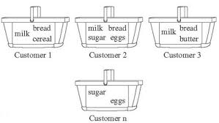
For example, if data shows that customers who buy bread and butter also tend to buy milk, retailers can place these items closer or offer combo discounts.

Advantages and Limitations
The main advantage of Market Basket Analysis is its ability to extract hidden knowledge from large datasets and convert it into actionable business insights. It improves customer satisfaction, increases sales, and enhances operational efficiency. However, MBA also has limitations. It may generate a large number of rules, many of which may be trivial or irrelevant. Additionally, it does not consider the sequence or time gap between purchases unless extended with sequential pattern mining.

Q.9 B/w supervised and unsupervised learning ?
Ans. Machine learning is broadly classified into supervised learning and unsupervised learning based on the availability of labeled data and the objective of learning. Both approaches play a vital role in data mining, pattern recognition, and predictive analytics, but they differ significantly in methodology, purpose, and outcomes.
Supervised Learning
Supervised learning is a machine learning technique in which the model is trained using labeled data, meaning that each input is associated with a known output. The primary objective is to learn a mapping function from input variables to output variables so that accurate predictions can be made for unseen data. This approach relies on prior knowledge in the form of training examples.
Supervised learning is mainly used for classification (e.g., spam detection, disease diagnosis) and regression (e.g., price prediction, demand forecasting). Since the expected output is known, model performance can be evaluated using metrics such as accuracy, precision, recall, and mean squared error. However, supervised learning requires a large amount of labeled data, which can be expensive and time-consuming to obtain.
Unsupervised Learning
Unsupervised learning, on the other hand, works with unlabeled data, where no predefined output is available. The goal is to identify hidden structures, patterns, or relationships within the data without external guidance. Instead of prediction, unsupervised learning focuses on data exploration and structure discovery.
Common tasks in unsupervised learning include clustering (grouping similar data points) and association rule mining (discovering relationships among variables). Since there are no correct output labels, evaluation is more subjective and often based on interpretability or domain relevance. Unsupervised learning is especially useful when dealing with large, raw datasets where labeling is impractical.
Comparative study between Supervised and Unsupervised Learning
Aspect | Supervised Learning | Unsupervised Learning
Type of Data | Labeled data | Unlabeled data
Output | Known and predefined | Unknown
Main Objective | Prediction or classification | Pattern and structure discovery
Learning Guidance | Guided by input–output pairs | No guidance, self-discovery
Common Tasks | Classification, regression | Clustering, association
Evaluation | Quantitative (accuracy, error rate) | Qualitative or interpretive
Complexity | Requires labeled datasets | No labeling cost, but harder to validate

Q.10 What is Bayesian classification?
Ans. Bayesian classification is a probabilistic approach to classification that is based on Bayes’ theorem. It is one of the most fundamental techniques in data mining and machine learning for predicting class labels of data instances. Bayesian classification predicts the probability that a given data object belongs to a particular class and assigns the object to the class with the highest posterior probability. This approach is widely used because of its strong mathematical foundation, simplicity, and effectiveness in handling uncertainty. The theoretical basis of Bayesian classification lies in Bayes’ theorem, which describes the relationship between conditional probabilities. Bayes’ theorem states that the probability of a hypothesis given observed data is proportional to the probability of observing the data given the hypothesis multiplied by the prior probability of the hypothesis. In the context of classification, the hypothesis represents a class, and the observed data represents the attribute values of a data instance. The goal of Bayesian classification is to compute the posterior probability of each class and select the class with the maximum probability.
Mathematically, Bayes’ theorem can be expressed as the posterior probability of a class being equal to the likelihood of the data given that class multiplied by the prior probability of the class, divided by the probability of the data. The prior probability represents the initial belief about the class before observing the data, while the likelihood represents how well the data supports the class. The denominator acts as a normalization factor to ensure that probabilities sum to one. A widely used form of Bayesian classification is the Naïve Bayes classifier. The Naïve Bayes classifier assumes that the attributes are conditionally independent given the class label. Although this assumption is often unrealistic in real-world data, the classifier performs surprisingly well in practice. The independence assumption simplifies probability computation and makes the classifier computationally efficient, even for large datasets. The working of Bayesian classification begins with training the model using labeled data. During training, the prior probabilities of classes and the conditional probabilities of attributes given classes are calculated. When a new data instance is presented, the classifier computes the posterior probability for each class using Bayes’ theorem. The instance is then assigned to the class with the highest posterior probability. This process makes Bayesian classification suitable for both binary and multi-class problems.
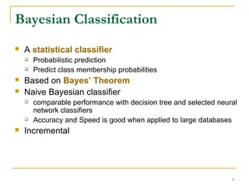

Bayesian classification has several important advantages. It is simple to implement and computationally efficient. It works well with high-dimensional data and performs effectively even with small training datasets. It is robust to noise and can handle missing values gracefully. Bayesian classifiers also provide probabilistic outputs, which are useful for decision-making under uncertainty. Despite its advantages, Bayesian classification has certain limitations. The independence assumption in Naïve Bayes may not hold true for many real-world datasets, which can affect accuracy. Estimating probabilities for continuous attributes may require assumptions about data distribution. Bayesian classifiers also rely heavily on accurate probability estimation, which can be challenging when data is sparse.
Bayesian classification is widely used in many real-world applications. In text mining, it is used for document classification and spam detection. In medical diagnosis, it helps in disease prediction. In finance, it is applied in credit risk assessment and fraud detection. In recommender systems and sentiment analysis, Bayesian classifiers play an important role.In conclusion, Bayesian classification is a powerful probabilistic approach to classification that uses Bayes’ theorem to predict class membership. Its mathematical rigor, efficiency, and ability to handle uncertainty make it a popular choice in data mining and machine learning. Despite certain assumptions and limitations, Bayesian classification remains an essential and widely used technique for predictive modeling and knowledge discovery.

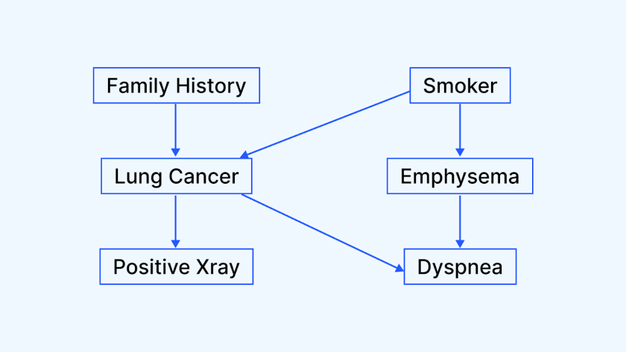
Fig -Example of Bayesian Classification

Q.11 Explain MARCOS chain model ?
Ans The Markov Chain model is a mathematical and probabilistic model used to describe systems that change from one state to another over time in a random manner. It is widely used in data mining, machine learning, statistics, and stochastic modeling. The fundamental concept of the Markov Chain is based on the assumption that the future state of a system depends only on its current state and not on the sequence of past states. This property is known as the Markov property or memoryless property. A Markov Chain consists of a finite or countable set of states and a set of transition probabilities that govern the movement from one state to another. At any given time, the system is in exactly one state, and at the next time step, it may transition to another state according to predefined probabilities. These probabilities are fixed and are usually represented in the form of a transition probability matrix. Each element of this matrix represents the probability of moving from one state to another, and the sum of probabilities in each row is always equal to one.
Mathematically, the Markov property states that the probability of the next state depends only on the present state and is independent of the past. This can be expressed as the conditional probability of the next state given the present state being equal to the conditional probability of the next state given the entire history of states. This simplifying assumption makes Markov Chains computationally efficient and suitable for modeling complex real-world processes.
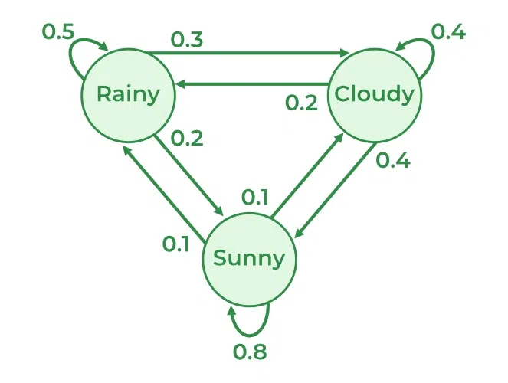
Markov Chains can be classified based on time and state characteristics. In a discrete-time Markov Chain, transitions occur at fixed time intervals, whereas in a continuous-time Markov Chain, transitions can occur at any instant. Based on state behavior, states can be categorized as absorbing, transient, or recurrent. An absorbing state is one that, once entered, cannot be exited. Transient states may be visited temporarily, while recurrent states are visited repeatedly over time. An important concept in Markov Chains is the steady-state or stationary distribution. The steady-state distribution represents the long-run probability of the system being in each state, regardless of the initial state. If a Markov Chain is irreducible, aperiodic, and finite, it will converge to a unique stationary distribution. This concept is extremely useful in long-term prediction and equilibrium analysis.
In data mining and analytics, Markov Chains are used to model sequential and temporal data. In web usage mining, user navigation between web pages is modeled as state transitions. In text and speech processing, Markov Chains model sequences of words or phonemes. In finance, they are used to model stock price movements and credit rating transitions. In biology, Markov Chains are applied to genetic sequence analysis and protein structure modeling.Markov Chains also serve as the foundation for advanced probabilistic models such as Hidden Markov Models (HMMs). In HMMs, the states are not directly observable, but observable outputs are generated based on hidden states. HMMs are widely used in speech recognition, handwriting recognition, bioinformatics, and natural language processing.

Despite their wide applicability, Markov Chains have certain limitations. The assumption of memorylessness may not always hold true in real-world systems where past behavior influences future outcomes. Additionally, when the number of states becomes very large, the computational complexity increases significantly. However, due to their simplicity, mathematical rigor, and interpretability, Markov Chains remain one of the most powerful tools for modeling stochastic and sequential processes .In conclusion, the Markov Chain model is a fundamental probabilistic framework for modeling systems that evolve over time based on state transitions. Its memoryless property, transition probability structure, and ability to model uncertainty make it highly valuable in data mining, machine learning, and predictive modeling. By effectively capturing sequential behavior, Markov Chains provide deep insights into the dynamics of complex systems and play a crucial role in modern data analysis.

Q.12 Describe the "Hierarchical Clustering" method ?
Ans. Hierarchical clustering is an unsupervised learning technique used to group data objects into clusters based on their similarity or distance. Unlike partition-based methods (such as k-means), hierarchical clustering does not require the number of clusters to be specified in advance.It builds a hierarchy of clusters, which can be visualized using a tree-like structure called a dendrogram. This hierarchy shows how clusters are formed step by step at different similarity (or distance) levels.
Hierarchical clustering is especially useful when:
- The structure of data is unknown,
- Exploratory data analysis is required,
- Relationships among clusters need to be visualized.
Types of Hierarchical Clustering
Hierarchical clustering can be broadly classified into two main types:
(i) Agglomerative Hierarchical Clustering (Bottom-Up Approach)
Each data object starts as an individual cluster. At every step, the two closest (most similar) clusters are merged. This process continues until: All objects form a single cluster, or A desired number of clusters is obtained.
(ii) Divisive Hierarchical Clustering (Top-Down Approach)
All data objects start in one single cluster. At each step, the cluster is split into smaller clusters. The process continues until: Each object forms its own cluster, or A stopping criterion is met.
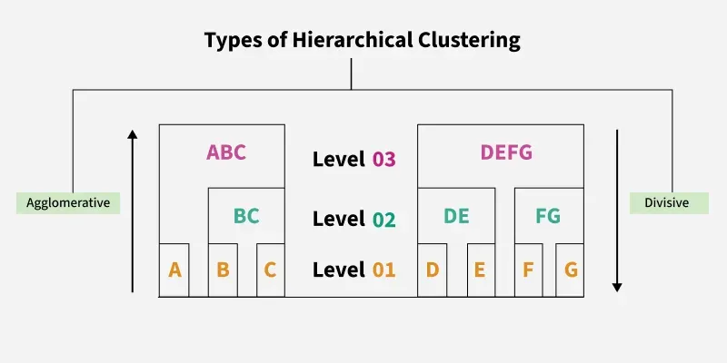

Advantages of Hierarchical Clustering
- No need to specify the number of clusters in advance.
- Provides a clear visual representation using dendrograms.
- Works with any distance metric.
- Useful for exploratory data analysis.
- Captures nested cluster structures.

Limitations of Hierarchical Clustering
- Computationally expensive for large datasets
- (Time complexity ≈ O(n3)O(n^3)O(n3)).
- Once a merge or split is made, it cannot be undone.
- Sensitive to noise and outliers.
- Not suitable for very high-dimensional data.
- Performance depends heavily on the choice of distance metric and linkage method.

Applications of Hierarchical Clustering
- Biology: Gene expression analysis, taxonomy.
- Marketing: Customer segmentation.
- Text Mining: Document clustering.
- Image Processing: Image segmentation and pattern recognition.
- Social Network Analysis: Community detection.

Q.13 What is Data Pre processing ?
Ans. Data preprocessing is an essential step in data mining and machine learning that involves preparing raw data into a clean, consistent, and usable format before applying analytical or mining techniques. In real-world applications, data collected from various sources is often incomplete, noisy, inconsistent, and unstructured. If such raw data is directly used for analysis, it may lead to inaccurate results and misleading conclusions. Therefore, data preprocessing improves data quality and ensures reliable and meaningful outcomes. The main objective of data preprocessing is to enhance the accuracy, efficiency, and performance of data mining algorithms. High-quality data leads to better models and more accurate predictions. Data preprocessing helps in removing errors, handling missing values, resolving inconsistencies, and transforming data into a suitable format. It also reduces data complexity and storage requirements.
Data preprocessing consists of several important steps, beginning with data cleaning. Data cleaning focuses on removing noise, correcting incorrect values, handling missing data, and eliminating duplicate records. Missing values can be handled by filling them with mean or median values, using predictive models, or removing the incomplete records. Noise and outliers are handled using smoothing techniques such as binning, regression, and clustering.Another important step is data integration, where data from multiple sources is combined into a single dataset. During integration, conflicts in naming conventions, data formats, and measurement units are resolved. Data redundancy and inconsistency are also minimized to improve data consistency.
Data transformation is the process of converting data into appropriate forms suitable for mining. It includes normalization, aggregation, generalization, and encoding. Normalization scales data values to a specific range, which improves algorithm performance. Aggregation summarizes data, while generalization replaces low-level data with higher-level concepts.

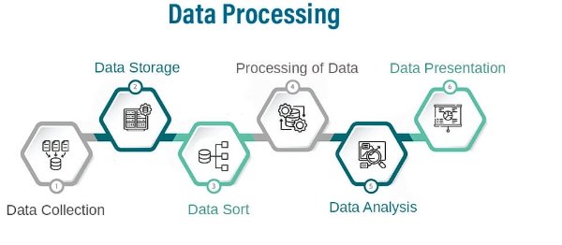
Data reduction is also a key component of data preprocessing. It reduces the volume of data while maintaining essential information. Techniques such as dimensionality reduction, sampling, and compression are used to reduce computational cost and improve efficiency.
In conclusion, data preprocessing is a crucial foundation of data mining and analytics. It ensures that data is accurate, complete, consistent, and well-structured. Effective data preprocessing significantly enhances the quality of analysis and leads to better decision-making and knowledge discovery.
Q.14 Define the technique for data cleaning data, Data reduction?
Ans. Data cleaning and data reduction are two important steps of data preprocessing in data mining and knowledge discovery. The quality of data directly affects the accuracy and reliability of data mining results, and therefore these techniques play a crucial role in preparing data for effective analysis .Data cleaning is the process of detecting and correcting errors, inconsistencies, and inaccuracies present in data. In real-world datasets, data is often incomplete, noisy, or inconsistent due to human errors, system failures, or data integration from multiple sources. If such data is used directly for mining, it may lead to incorrect or misleading patterns. Hence, data cleaning improves data quality and ensures reliability. One common problem addressed by data cleaning is missing data. Missing values can occur when data is not recorded or is lost during transmission. Missing data can be handled by ignoring the record, filling the missing value manually, replacing it with a global constant, or estimating it using statistical methods such as mean, median, or regression-based prediction. Each method is chosen depending on the nature of data and application.
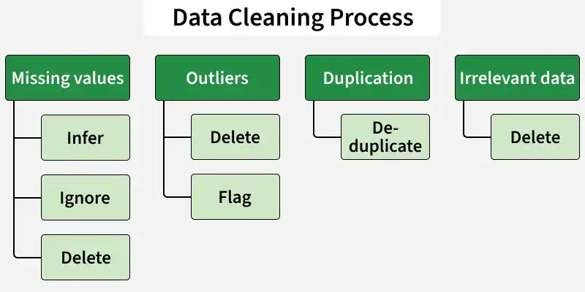

Another major issue is noisy data, which contains random errors or outliers. Noise can distort analysis and reduce model accuracy. Noise can be handled using smoothing techniques such as binning, where data values are grouped and replaced with average values. Regression techniques are also used to smooth data by fitting a function to it. Clustering techniques can identify and remove outliers that do not belong to any cluster. Inconsistent data occurs when the same information is represented differently in different records. This often happens during data integration from multiple sources. Inconsistencies can be resolved using data validation rules, domain constraints, and manual correction. Duplicate data records are also removed during cleaning to avoid redundancy.
Data reduction, on the other hand, aims to reduce the size of the dataset while preserving its important information. Large datasets increase storage requirements and computational cost, making data mining inefficient. Data reduction techniques help improve performance without significantly affecting results. One important data reduction technique is dimensionality reduction, which reduces the number of attributes in a dataset. This can be achieved through feature selection, where irrelevant or redundant attributes are removed, or through feature extraction, where new features are created by combining existing ones. Dimensionality reduction reduces complexity and improves model accuracy. Another data reduction method is numerosity reduction, where the volume of data is reduced by replacing it with a smaller representation. Techniques such as sampling, aggregation, and data compression are used. Sampling selects a representative subset of data. Aggregation combines data into summary forms such as totals or averages. Data compression encodes data in a reduced form. In conclusion, data cleaning ensures accuracy and consistency, while data reduction improves efficiency and scalability. Both techniques are essential preprocessing steps that enhance the effectiveness of data mining and knowledge discovery processes.
Q.15 What is Data cube aggregation and dimensionality reduction ?
Ans. Data cube aggregation and dimensionality reduction are advanced data preprocessing techniques used in data warehousing and data mining to support efficient data analysis and decision-making. These techniques help manage large, complex datasets and improve query performance and analytical efficiency. Data cube aggregation is a technique used in multidimensional data analysis, particularly in data warehouses. A data cube represents data along multiple dimensions such as time, location, and product. Each dimension may have multiple levels of hierarchy. Data cube aggregation summarizes detailed data into higher-level information by performing aggregation operations such as sum, count, average, minimum, and maximum. For example, sales data can be aggregated from daily sales to monthly or yearly sales. Similarly, data can be aggregated from city level to state or country level. This allows users to analyze data at different levels of abstraction. Data cube aggregation supports operations such as roll-up, drill-down, slice, and dice, which help users explore data interactively.

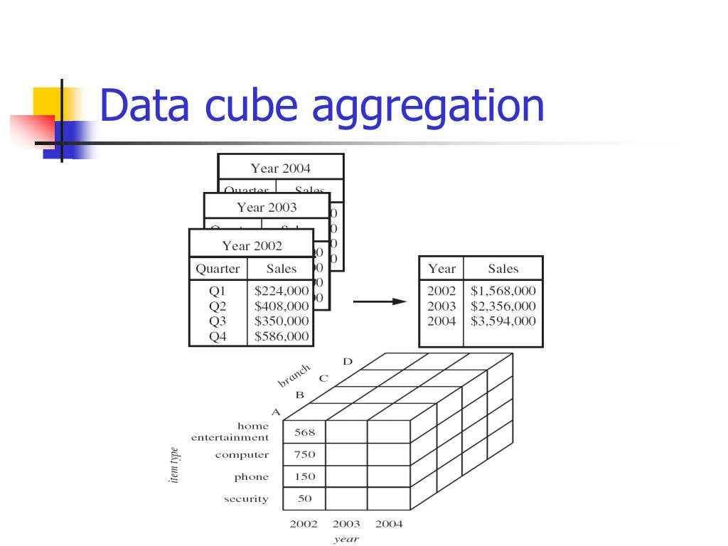
The main advantage of data cube aggregation is improved query performance. Instead of computing results from raw data every time, pre-aggregated data can be used, significantly reducing response time. It also helps users focus on summarized trends rather than excessive details, making analysis more meaningful. However, data cube aggregation increases storage requirements because aggregated values for all dimension combinations need to be stored. Therefore, partial materialization techniques are often used, where only frequently used aggregations are stored. Dimensionality reduction is another important technique used to reduce the number of attributes or dimensions in a dataset. High-dimensional data increases computational complexity and may lead to problems such as the curse of dimensionality, where data becomes sparse and difficult to analyze. Dimensionality reduction addresses this issue by reducing the number of variables while retaining essential information. There are two main approaches to dimensionality reduction: feature selection and feature extraction. Feature selection involves selecting a subset of relevant attributes and eliminating redundant or irrelevant ones. This improves model interpretability and reduces noise. Feature extraction transforms original attributes into a smaller set of new features using mathematical techniques such as Principal Component Analysis (PCA).Dimensionality reduction improves the efficiency of data mining algorithms, reduces storage space, and enhances model accuracy. It also helps visualize high-dimensional data in lower dimensions.
In conclusion, data cube aggregation and dimensionality reduction are powerful techniques for handling large-scale and complex datasets. Data cube aggregation enables fast and flexible multidimensional analysis, while dimensionality reduction simplifies data representation and improves computational performance. Together, they form a strong foundation for efficient data analysis in modern data warehousing and data mining systems.

Submitted By:
Swati Dubey [DS7E2505]
M.Tech. II Sem - Data Science( Working Executive )

